**Genetics = the study of heredity** (guided notes)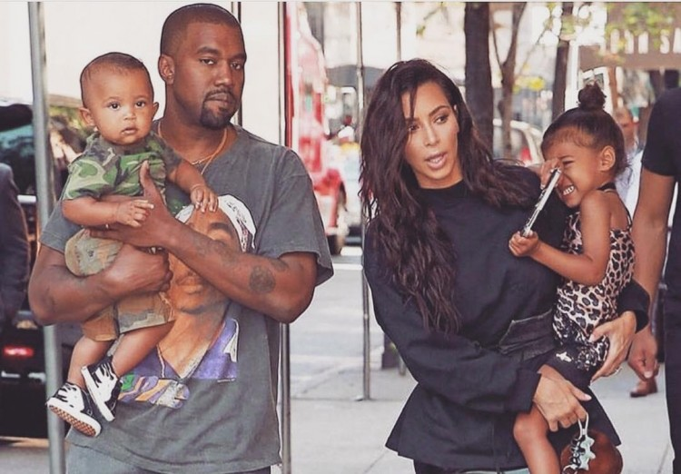

Heredity_ = how traits are passed from parents to offspring

Also referred to as Inheritance

**1. A Brief History of Genetics**

Blending Theory - offspring have a mix of traits, somewhere in between (Straight x curly = wavy)

Particulate Theory - traits are inherited as "particles", offspring receive a "piece"

**2. Consider Sickle Cell Disease**

In many cases, neither parent has the disease, but a child is born with sickle cell.

Does this support the blending theory or the particulate theory? particulate

Recall Alexandria’s Story from last chapter. What caused her to have sickle cell disease? What were her symptoms?

**3. In the case of sickle cell, the parents can be** carriers**.**

-They have the gene that causes the disorder, but they only have one copy.

-The other copy of the gene is normal, they can make normal blood cells.

-You always have 2 copies of a gene, one came from your mother and one came from your father.

- Genes are located on chromosomes, chromosomes occur in pairs

**4. Examine the feet below,** what do you notice about the second toe? It’s shorter than the big toe.

When we talk about traits we can see, we are referring to the **PHENOTYPE** In other words, phenotype refers to the appearance

**5. The Short Big Toe Trait**

We know that when two people with long big toes have children, they always have children with the same type. But...if two people with short big toes have children, sometimes they can have a child with the opposite type. Hmmm…

Sketch the short big toe trait:

**6. Some genes are dominant**

In the case of the toe trait, one gene is dominant  
 and can cover up the expression of the other gene.

With feet, the long big toe gene is Recessive

You need to have both copies of the gene to have this phenotype.

**7. A person’s Genotype is the underlying genetic code that determines their traits**

- this is based on a long sequence of bases found on DNA

- to simplify, genetics assign LETTERS to genotypes

- because you have two copies of every gene, your genotype will have two letters.

**8. Assigning Genotypes**

A capital letter is used for the dominant version of the gene and a lowercase letter is used for the recessive version.

T T = short big toe T t = _______________ tt = ____________________



**9. Toe Heredity**

How can a person have a long big toe (tt) if both of their parents have a short big toe (TT or Tt)?

First, both of her parents must be carrying the t gene, so her parents’ genotype is Tt

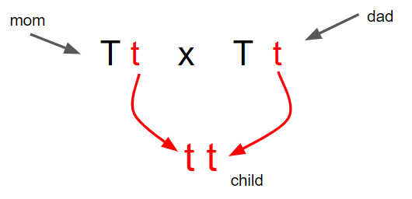

**10. What are the odds?**

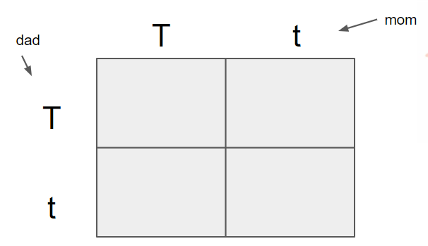

We can make predictions about what phenotypes the offspring will have using a _____________________ SQUARE

**11. Complete the Punnett Square** →

What is the chance that a child will be tt? _______

**12. The same method can be used to predict the outcome of another cross.**

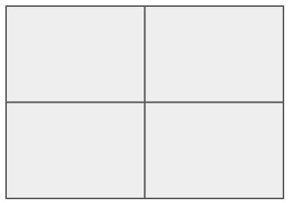

Mom has long big toes ( t t )   
 Dad has short big toes (T t)

What percentage of their offspring will take after mom (t t)?

What percentage will take after dad?

**13. Alex has sickle cell disease but neither of her parents do.**

What are the genotypes of her parents? 

____Ss____ x ___Ss_______

Set up and complete the Punnett square →

What is the probability (odds) that if Alex had a baby brother, that he would NOT have the disorder?

**14. Amoeba Sisters - Monohybrid Cross** (6 minutes)

1. An allele is a form of a ____________________ represented by a letter.

2. Dominant alleles are represented by a capital letters letter.

3. The genetic makeup of an organism is the genotype.

4. Only one dominant allele is necessary for a trait to show up. a) true b) false



5. HH and hh are both a) homozygous b) heterozygous



6. A heterozygous genotype would be represented by which combination: a) HH b) Hh c) hh



7. The root word “mono” means a) one b) two c) hairy



8. In the cross Hh x Hh, what percentage of offspring will be Hh a) 25 b) 50 c) 75



9. Hairy or hairless are examples of a) genotypes b) alleles c) phenotypes



10. Punnett squares show us predictions, or probabilities.

**15. A short history lesson**

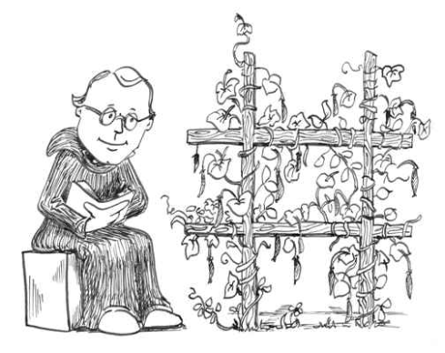

What we know about genetics and probability was established by   
   
 GREGOR ________________Mendel______________

He is known as the “Father of Genetics.”

He did experiments on pea plants where he learned about the principles of dominance and recessiveness and how traits are passed through each generation

**16. Traits in Pea Plants**

Seed shape Seed color ___________________

__________________ Pod color Flower Position ___________________

**17. Plant Sex**

Pea plants can be self-fertilized or _________cross-________________.   
 This helped Mendel figure out that some traits were hidden, he later called these traits “recessive.”

**18. True-Breeding Plants** -always create plants that look like the same

___________________________________ – offspring of true-breeding plants

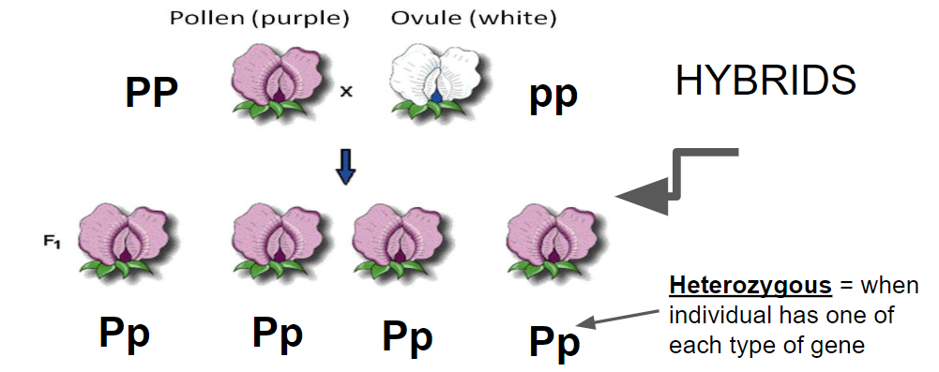

**19. Mendel discovered that each trait is controlled by two factors** (alleless)

Genes– factors that determine your traits, composed of two alleles

Genes are located on chromosomes

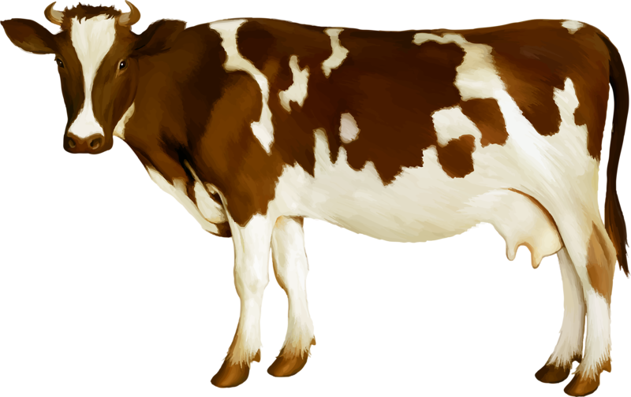

**20. There are other types of crosses…**

If you cross a red cow with a white cow, you get offspring that are red and white,   
a condition called _________________________________

This is called _________________________, because neither allele covers up the others and both are expressed.

**22. Dihybrid Crosses** - involve two traits

**23. Incomplete dominance** - white x red flower = pink flowers  
 What would happen if two pink flowers were crossed?

**24. Multiple Allele Traits**  more than two alleles control a trait, example: __________________

**25. Epistasis** - Sometimes a set of alleles can cover up another set.   
 Example: ______________________________________

**26. Polygenic Traits** - many genes control a trait, creates a _____________________ of phenotypes  
 Examples: _______________________________________